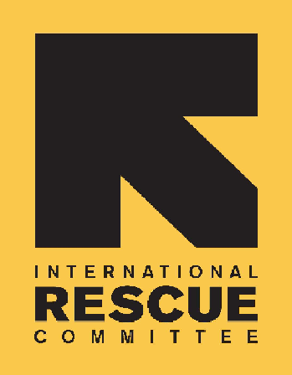
INTERNATIONAL RESCUE COMMITTEE, INC.
(Sudan Program)

BID NOTICE

Founded in 1933, the International Rescue Committee is a global humanitarian leader that helps people whose lives and livelihoods are shattered by conflict and disaster to survive, recover, and gain control of their future.

Required as follows:
The IRC is issuing Request for Proposals (RFPs) to solicit competitive sealed bids from qualified companies for: |  | Ref: #: IRC/2SDN/MSA/2025/01
Provision of Cash Distribution Services.
Lot A | Physical Cash delivery
Lot B | Digital Cash Transfer

Offers will not be accepted after close of business on the 17th of August 2025 at 4pm Central African Time

Disclaimer:
Please note that commercial banks that currently have an active long-term framework agreement with IRC Sudan are not required to apply for this tender.

